Current Operable Unit 3 Remedial Progress for Phase II Week Ending 6/11/10
Creamer Environmental Inc., National Grid’s Remediation Contractor, has excavated 3 out of 4 cells. To date 78 trucks have transported approximately 2,408 tons of soil to Bay Shore Soil Management (BSSM, formerly ESMI of NJ) for thermal desorption. Additionally 60,090 gallons of impacted excavation water has been disposed of at Clean Waters of Staten Island.
GEI, National Grid’s Remediation Oversight Consultant, will continue to perform CAMP (Community Air Monitoring Program) and Noise and Vibration monitoring. CAMP and Noise and Vibration monitoring will continue throughout the project.

Two-Week Outlook
Creamer Environmental Inc. will complete the excavation of cell 4 to design depth, remove the internal bracing system, and backfill the excavation. Creamer will also continue transportation and disposal of materials to BSSM for thermal desorption as well as disposal of impacted excavation water to Clean Waters of Staten Island. It is anticipated that the restoration phase of the project will be completed by week ending June 25th.
General hours of operation will continue to be Monday through Friday, 7:00 AM to 3:30 PM. However, work hours will be extended when necessary to maintain schedule or to complete critical tasks.

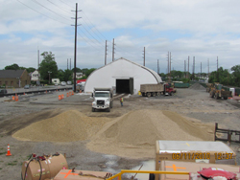
Loading soil trucks to Bay Shore recycling
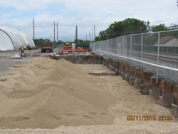
Backfilling of cells 1 and 2

